**Design intro and description**

The project is a stand-alone library checkout simulation of the themes from [checkoutthemes.com](http://checkoutthemes.com). We will show four languages from there on our language-option screen. We will use the configuration files provided at the site so that our program can, with only minor adjustments, show additional languages. With that and the requirements document in mind, we decided to go with Java, using JFrame to create the user interface.

That interface class will handle communicating with the user, and will communicate with other classes as needed. See the class diagram for a full overview.

The program will go through a series of screens, with the path shifting depending on what sort of input is received at what time. Mockups of the screens are appended to this document. The buttons will change in shape and placement as the screens are implemented and refined.

This document also contains our estimate on program size, as well as updated roles and scheduling info.

**Estimated Line of Code (L.O.C.) Count**

We estimated the size first by enumerating all the classes we intend to implement and made a rough estimate of the number of methods we think will be needed for these classes. Then we made a size estimate, figuring how large we think our methods will be on average. Then we took the multipliers given in a class slide, which while for C++, should be relatively similar for our Java-based program. Finally we did the math, which is shown in the following table.

|  |  |  |  |  |  |
| --- | --- | --- | --- | --- | --- |
| **Name** | **Type** | **Size estimate** | **# of methods** | **Multiplier** | **Total** |
| Self-checkout | Setup | VS | 2 | 3.88 | 7.76 |
| UI | I/O | S | 23 | 12.06 | 277.38 |
| Language | Text | S | 5 | 8 | 40 |
| Control | Logic | S | 15 | 10.98 | 164.7 |
| ObjectList | Data | S | 4 | 4.79 | 19.16 |
| PatronListDB | Data | S | 6 | 4.79 | 28.74 |
| ItemListDB | Data | S | 6 | 4.79 | 28.74 |
| Patron | Data | S | 5 | 4.79 | 23.95 |
| Item | Data | S | 5 | 4.79 | 23.95 |
|  |  |  |  |  |  |
|  |  |  |  | **Total** | 614.38 |

**Class Diagram**

The class diagram below describes the core classes we intend to implement. Along with labels and relationships between each class, the class diagram notes essential data-members and methods which we know will be necessary for successful implementation of our [[checkoutthemes.com](http://checkoutthemes.com)](http://checkoutthemes.com) simulation.

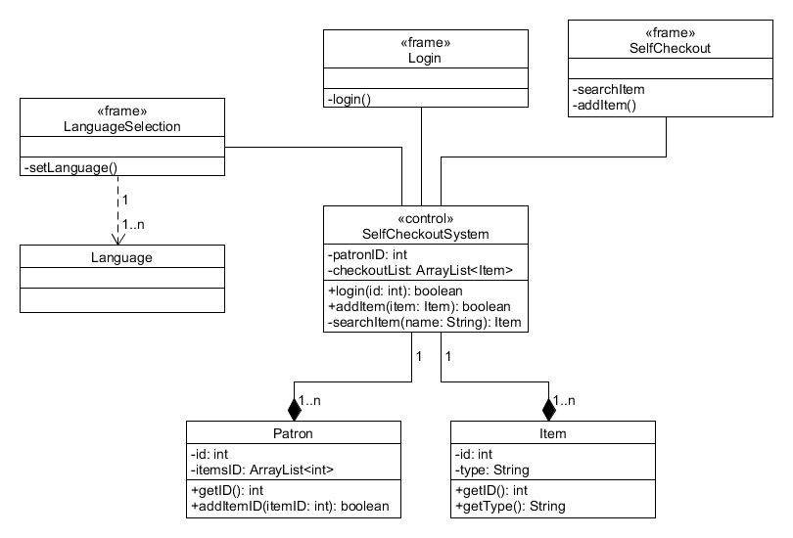

**Finite State Machine**

This is the Finite State Diagram which illustrates the behavior of our system once completed.



**Mock GUI**

This is what we expect our GUI to look like. There may be some minor stylistic changes to font and colors.

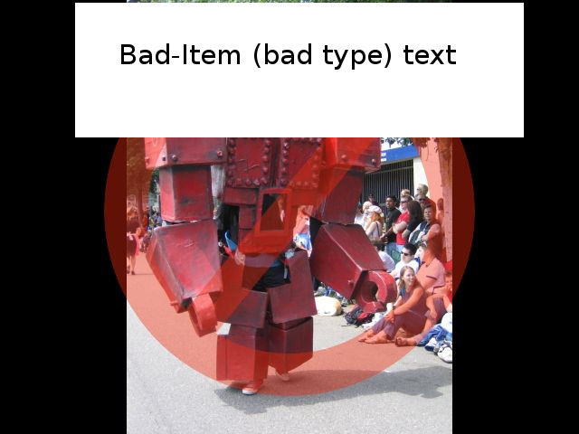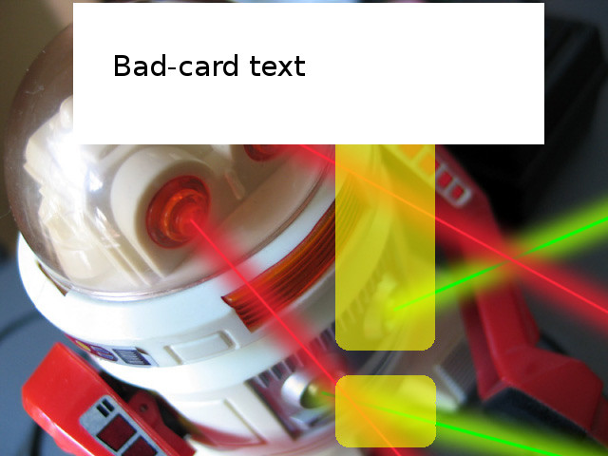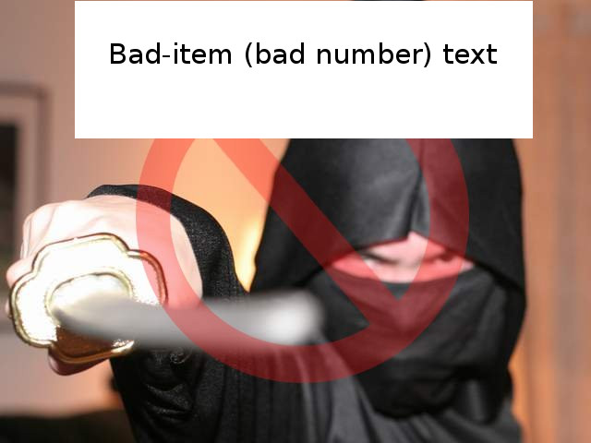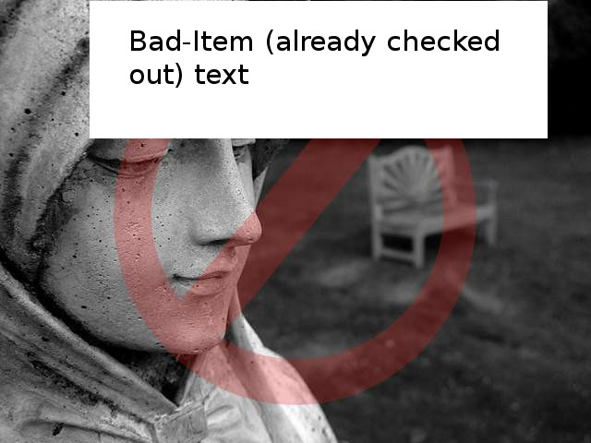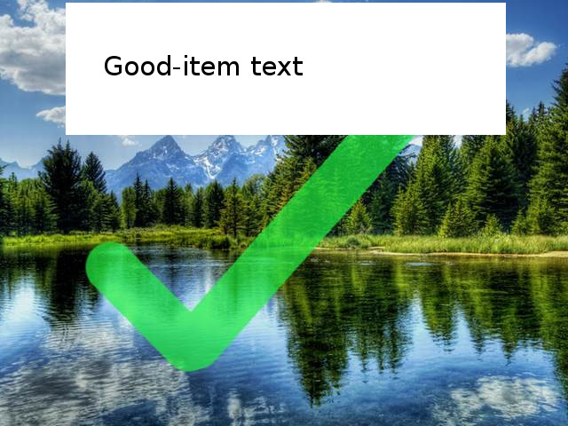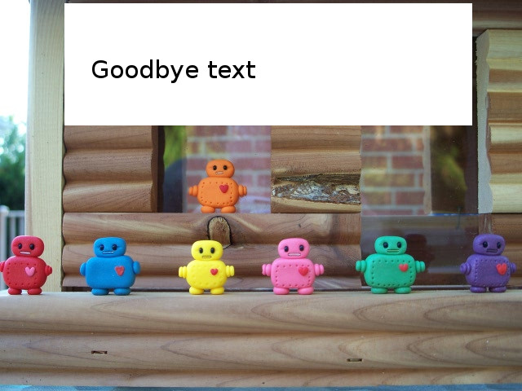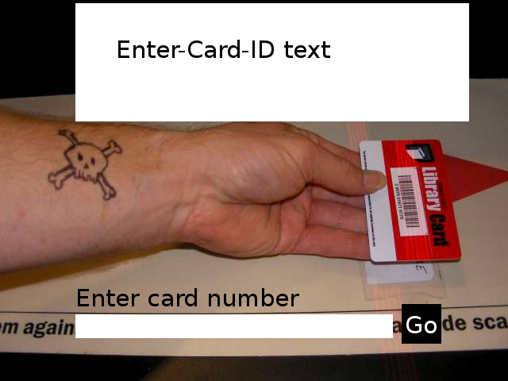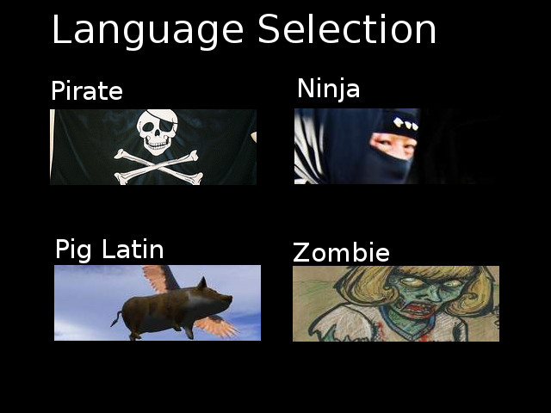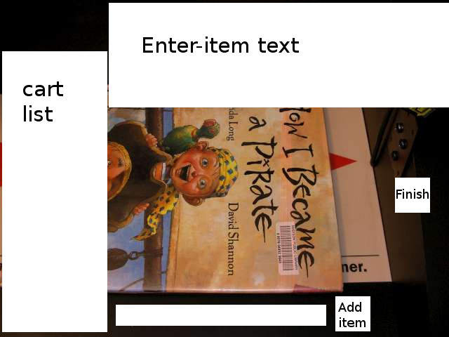

**Projected Team Schedule**

Below is our projected team schedule beginning with our submission of the independent inspection for our design document, through the submission of our beta version for review by Dr. Meqdadi.

|  |  |
| --- | --- |
| Nov 22nd | Submit design document for independent inspection. |
| Nov 23rd | Inspect group A3’s design document. |
| Nov 23rd | Return group A3’s inspected document. |
| Nov 25th – 26th | 26th – Review inspected design document. |
| Nov 27th | Final meeting to discuss design document. |
| Nov 29th | Submit final design document. |
| Nov 30th | Work on implementation |
| Dec 4th | Finish beta version |
| Dec 7th | Submit beta version |

**Team Roles**

|  |  |  |
| --- | --- | --- |
| **Title** | **Role** | |
| **Andrew J Brutlag** | **Requirement Phase** | Requirements Validation |
| **Design Phase** | Development Team Leader, Development Team Member |
| **Implementation phase** | Development Team Leader, Development Team Member |
| **Requirement Phase Tasks** | | |
| * Assist in requirements identification * Final Draft Use Case Diagram * Contributed to Data Dictionary | | |
| **Design phase Tasks** | | |
| * Assist in Architecture * Assist in Development Plan * Helped with layout of User Interface * Helped with class structure | | |
| **Implementation Phase Tasks** | | |
| * Assist in coding * Assist in testing * (to be determined) | | |

**Team Roles (cont.)**

|  |  |  |
| --- | --- | --- |
| **Title** | **Role** | |
| **Clay April Monoceros** | **Requirement Phase** | Client Engineer, Requirements Analyst |
| **Design Phase** | Development Team Member, Program Architect |
| **Implementation phase** | User Documentation, Development Team Member |
| **Requirement Phase Tasks** | | |
| * Assist in requirements identification * Write Program Purpose and Intended Outcome * First Draft Use Case Diagram * Contributed to Data Dictionary | | |
| **Design phase Tasks** | | |
| * Assist in Architecture * Assist in Development Plan * Wrote intro/description * Generated “demo” images for User Interface * Assist with designing class structure | | |
| **Implementation Phase Tasks** | | |
| * Assist in coding * Assist in testing * (to be determined) | | |

**Team Roles (cont.)**

|  |  |  |
| --- | --- | --- |
| **Title** | **Role** | |
| **Jose Martin** | **Requirement Phase** | Project Leader |
| **Design Phase** | Project Leader, Development Team Member, Program Architect |
| **Implementation phase** | Project Leader, Development Team Member |
| **Requirement Phase Tasks** | | |
| * Create schedule * Coordinate meetings * Assist in requirements identification * Generate final requirements document | | |
| **Design phase Tasks** | | |
| * Assist in Architecture * Assist in Development Plan * Assembled design document * Assisted with designing class structure * Assisted with User Interface design | | |
| **Implementation Phase Tasks** | | |
| * Assist in coding * Assist in testing * (to be determined) | | |

**Team Roles (cont.)**

|  |  |  |
| --- | --- | --- |
| **Title** | **Role** | |
| **Thiago Vilella Waideman Puga** | **Requirement Phase** | Requirements Validation |
| **Design Phase** | Development Team Member, Program Architect |
| **Implementation phase** | Development Team Member |
| **Requirement Phase Tasks** | | |
| * Assist in requirements identification * First Draft Use Case Diagram * Contributed to Data Dictionary | | |
| **Design phase Tasks** | | |
| * Assist in Architecture * Assist in Development Plan * Generated class diagram * Assisted with designing class structure * Assisted with designing User Interface | | |
| **Implementation Phase Tasks** | | |
| * Assist in coding * Assist in testing * (to be determined) | | |